**Low Level Design (LLD)**

**PRESCRIPTION LABEL READING**



Content

1. Introduction……………………………………………………………………………………….4
   1. What is Low Level Design Document?.................................................................4
   2. Scope……………………………………………………………………………………4
   3. Project Introduction……………………………………………………………………4
2. Problem Statement.……………………………………………………………………………...4
3. Dataset Information……………………………………………………………………….……...4
4. Architecture…………………………………………………………………………………….…4

# 1. Introduction

## 1.1 What is Low Level Design Document?

The goal of the Low-level design document (LLDD) is to give the internal logic design of the actual program code for the Heart Disease Diagnostic Analysis dashboard. LLDD describes the class diagrams with the methods and relations between classes and programs specs. It describes the modules so that the programmer can directly code the program from the document.

**1.2 What is Scope?**

Low-level design (LLD) is a component-level design process that follows a step by-step refinement process. The process can be used for designing data structures, required software architecture, source code and ultimately, performance algorithms. Overall, the data organization may be defined during requirement analysis and then refined during data design work.

## 1.3 Project Introduction

* Support elderly or vulnerable patients should be a focus for many businesses.
* This is especially true for those in the health care sector.
* Enabling voice messages can make it easier for elderly people to understand your message.
* Text-to-Speech can provide peace of mind by empowering you to give better services.
* For example, you could even send voice messages that read prescription labels.
* This can be a real challenge for anyone with reading difficulties, not to mention the elderly and visually impaired.
* A talking label, sent straight to your device, makes it easy to know everything about your medication.
* Dosage info can also be tracked and shared with caregivers.

# 2. Problem Statement

You need to apply OCR techniques to extract the text data from the prescriptions and convert them into speech.

You must build a solution that should recognize and identify the text in the prescriptions and should read out the name of medicines and dosage limits to the visually impaired patients.

# 3. Dataset Information:

Captured images are uploaded to the model.

# 4. Architecture

## 4.1 Architecture Description

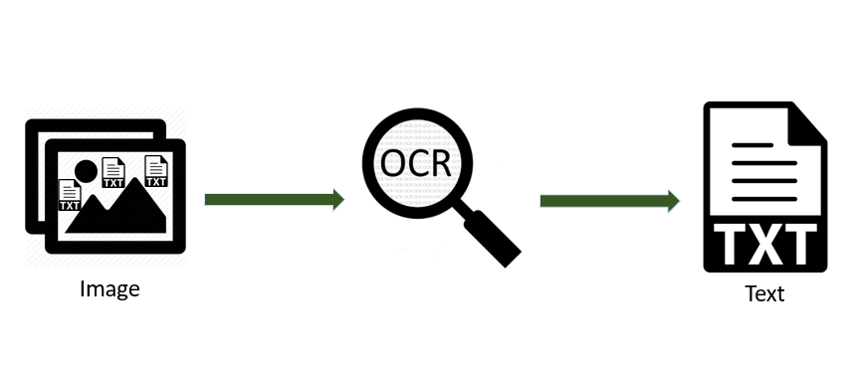



### Reporting

Reporting is a most important and underrated skill of a data analytics field. Because being a Data Analyst you should be good in easy and self-explanatory report because your model will be used by many stakeholders who are not from technical background.

1. High Level Design Document (HLD)
2. Low Level Design Document (LLD)
3. Architecture
4. Wireframe
5. Detailed Project Report
6. Power Point Presentation